app/code/Lmap/ExtAttributes/view/frontend/web/js/action/set-shipping-information-mixin.js

This java script mixin file had code line to copy custom attributes to extension attributes

shippingAddress['extension_attributes']['suburb'] = shippingAddress.customAttributes['suburb'];

This line was taken from magento documentation

<https://devdocs.magento.com/guides/v2.3/howdoi/checkout/checkout_new_field.html>

Using this line was giving following error when next button was pressed at shipping stage of checkout



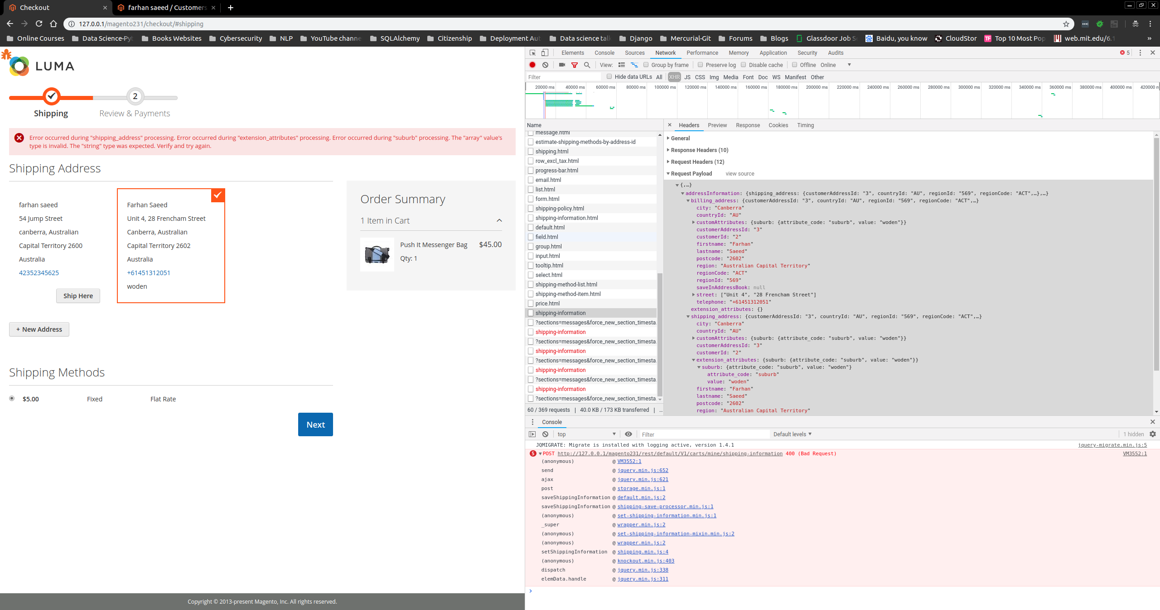

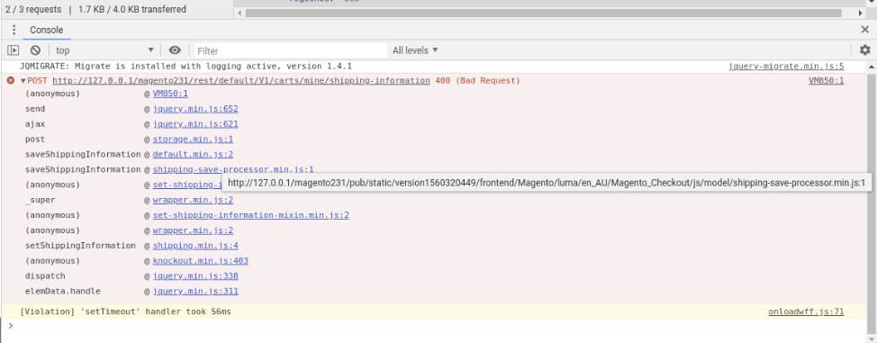

Hence ‘value’ key was appended

shippingAddress['extension_attributes']['suburb'] = shippingAddress.customAttributes['suburb'][‘value’];

and this removed the error and passed suburb field value as string to extension attributes ‘suburb’ key

